BeReal Clone: Walkthrough

**⚠️ Note: Unfortunately, this is the only form of demonstration I can provide. I’ve been working exclusively on FIU library computers, which in most of cases and programs failed to run iOS simulators due to extremely outdated and underpowered hardware. Additionally, these machines do not allow the installation of third-party recording software such as OBS or screen capture tools. Because of these constraints, I was unable to create a proper walkthrough video.**

**However, I have included screenshots along with detailed explanations of every part of the code I wrote myself, so reviewers can clearly understand the core functionality and logic behind the app.**

This document provides a walkthrough of the BeReal Clone (Part 1) iOS application. Each section corresponds to different parts of the project, with descriptions and related code screenshots.

AppDelegate.swift

Initializes Parse SDK when the app launches.

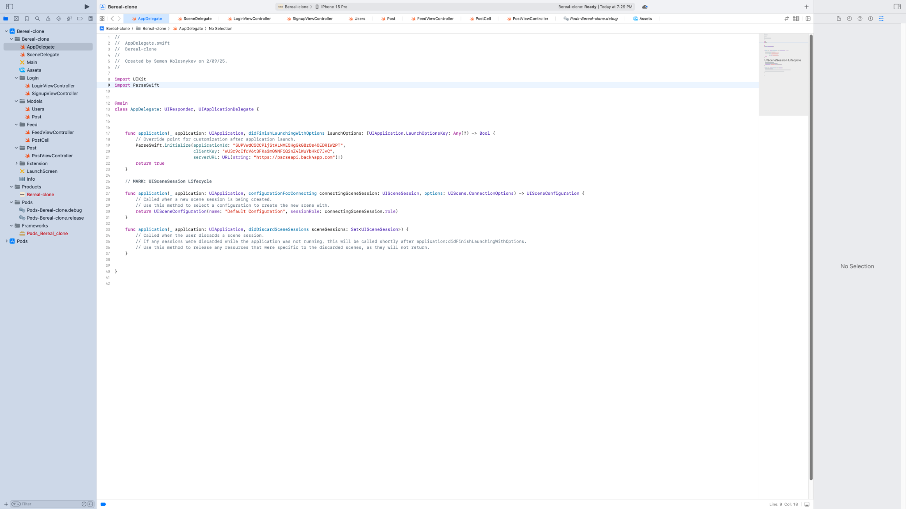

SceneDelegate.swift

Handles login/logout flow and switches root view controller based on user's state.

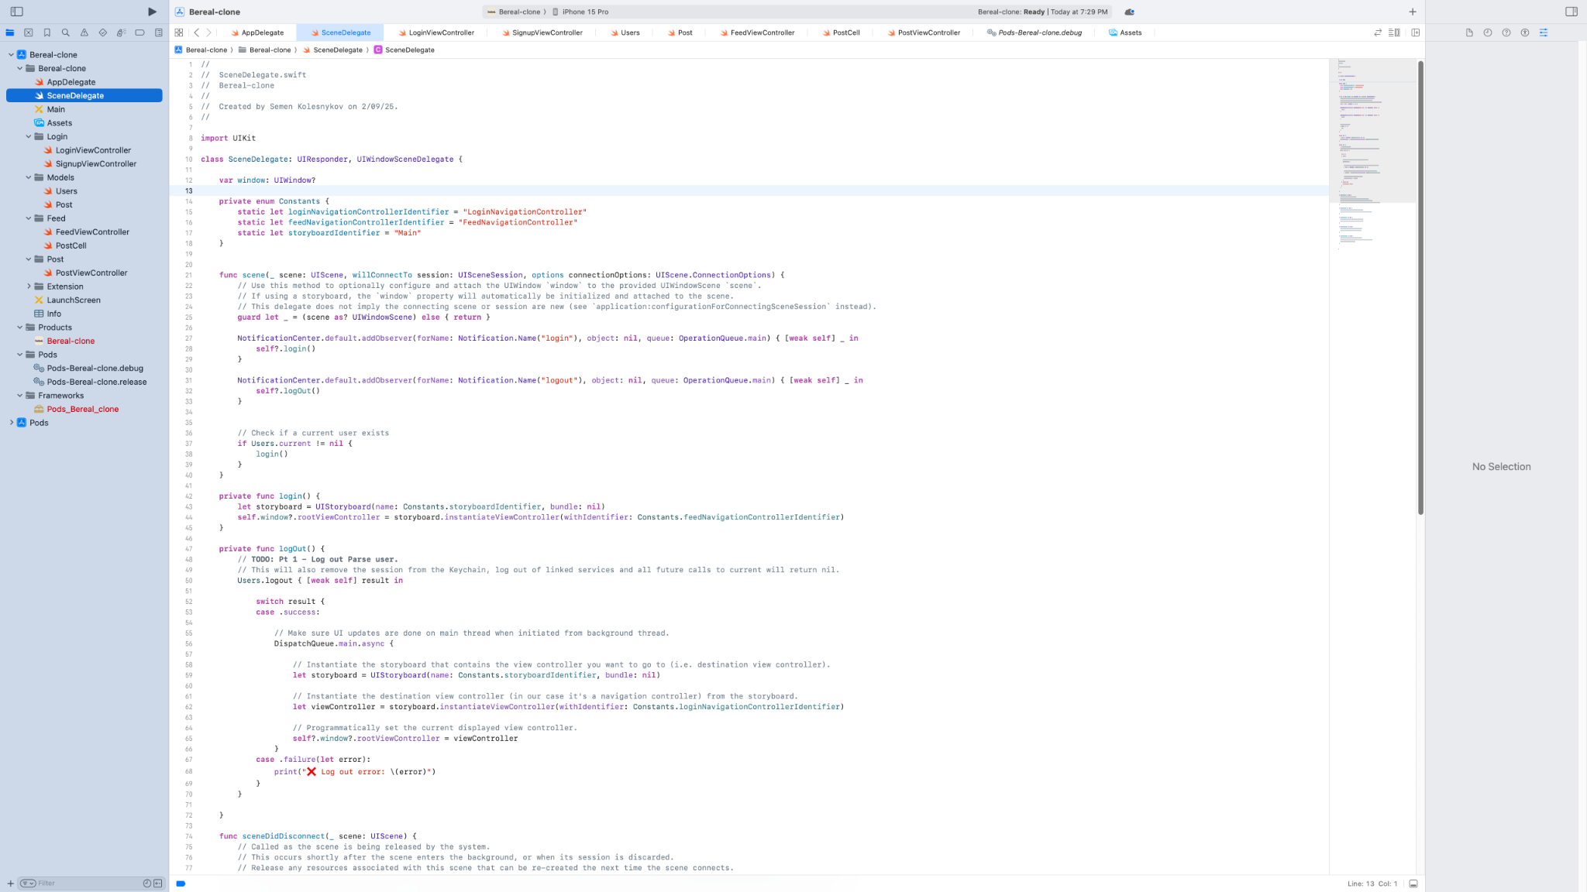

LoginViewController.swift

Login screen where users enter their credentials and log in.

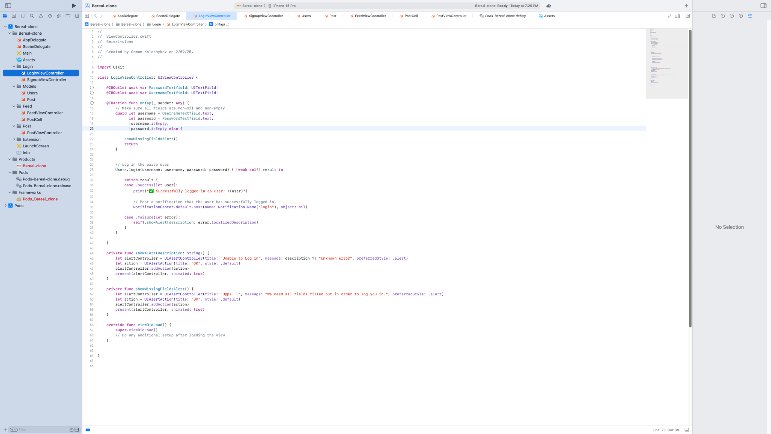

SignupViewController.swift

Signup screen for new users to create an account.

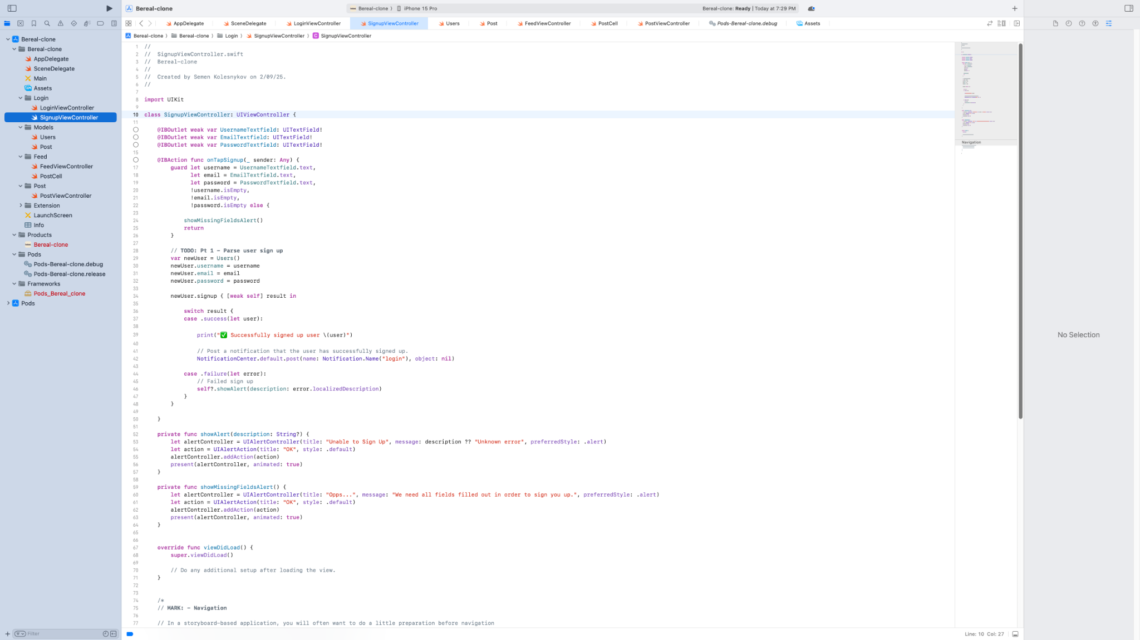

FeedViewController.swift (1/2)

Displays a feed of posts with pull-to-refresh and logout logic.

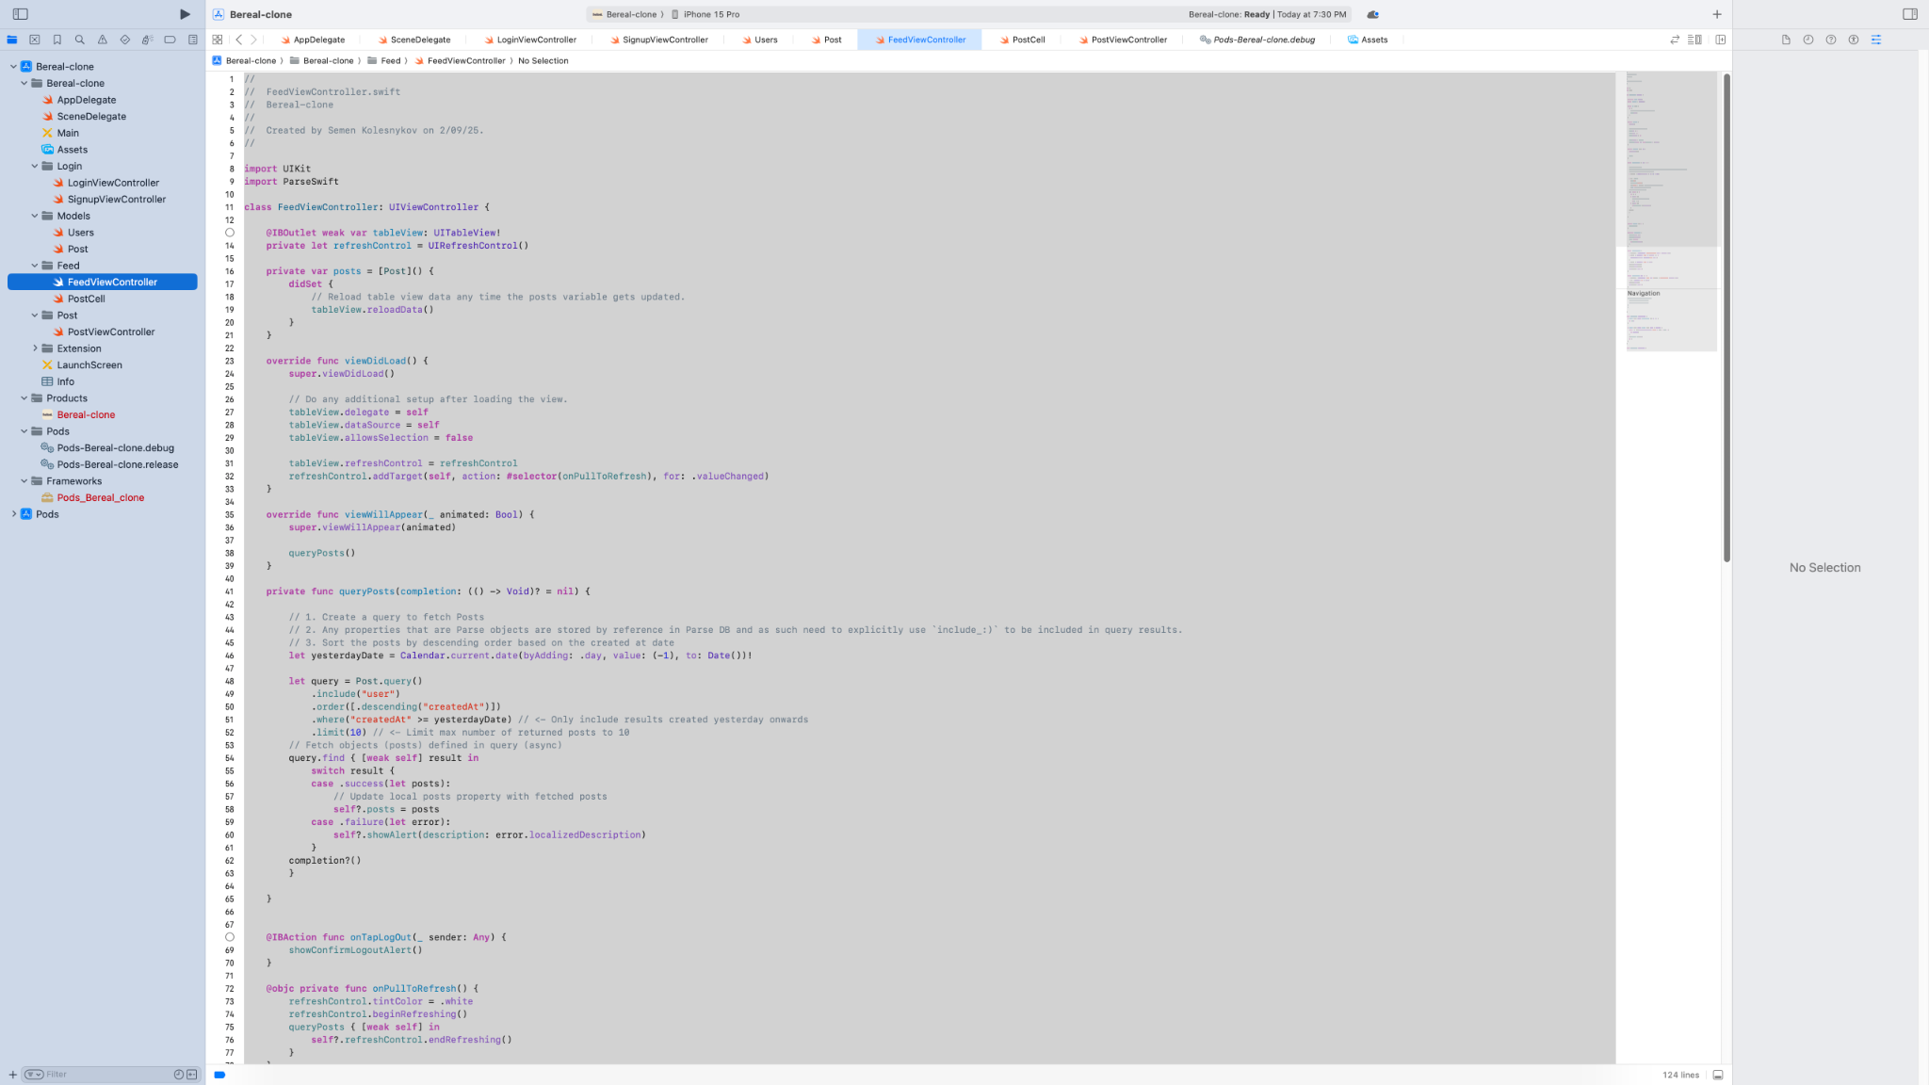

FeedViewController.swift (2/2)

Handles logout confirmation and table view cell configuration.

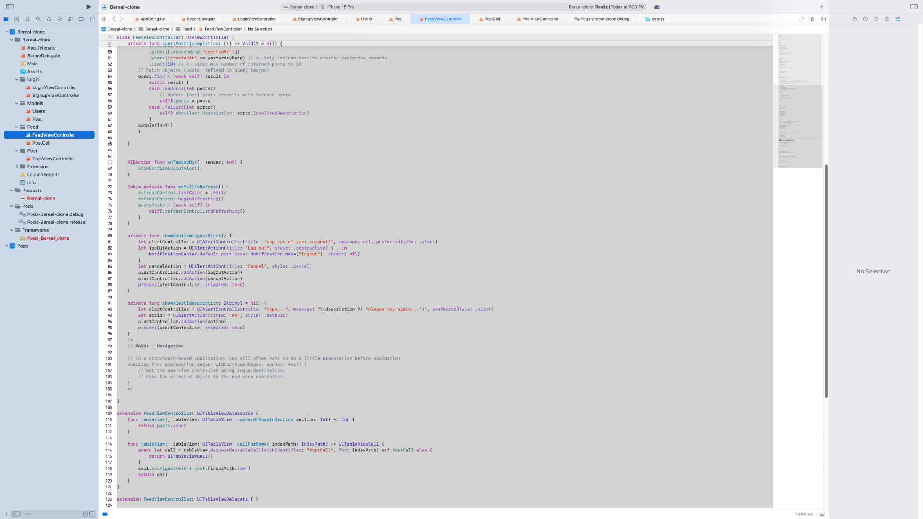

PostCell.swift

Custom table view cell that displays a post, with optional blur effect.

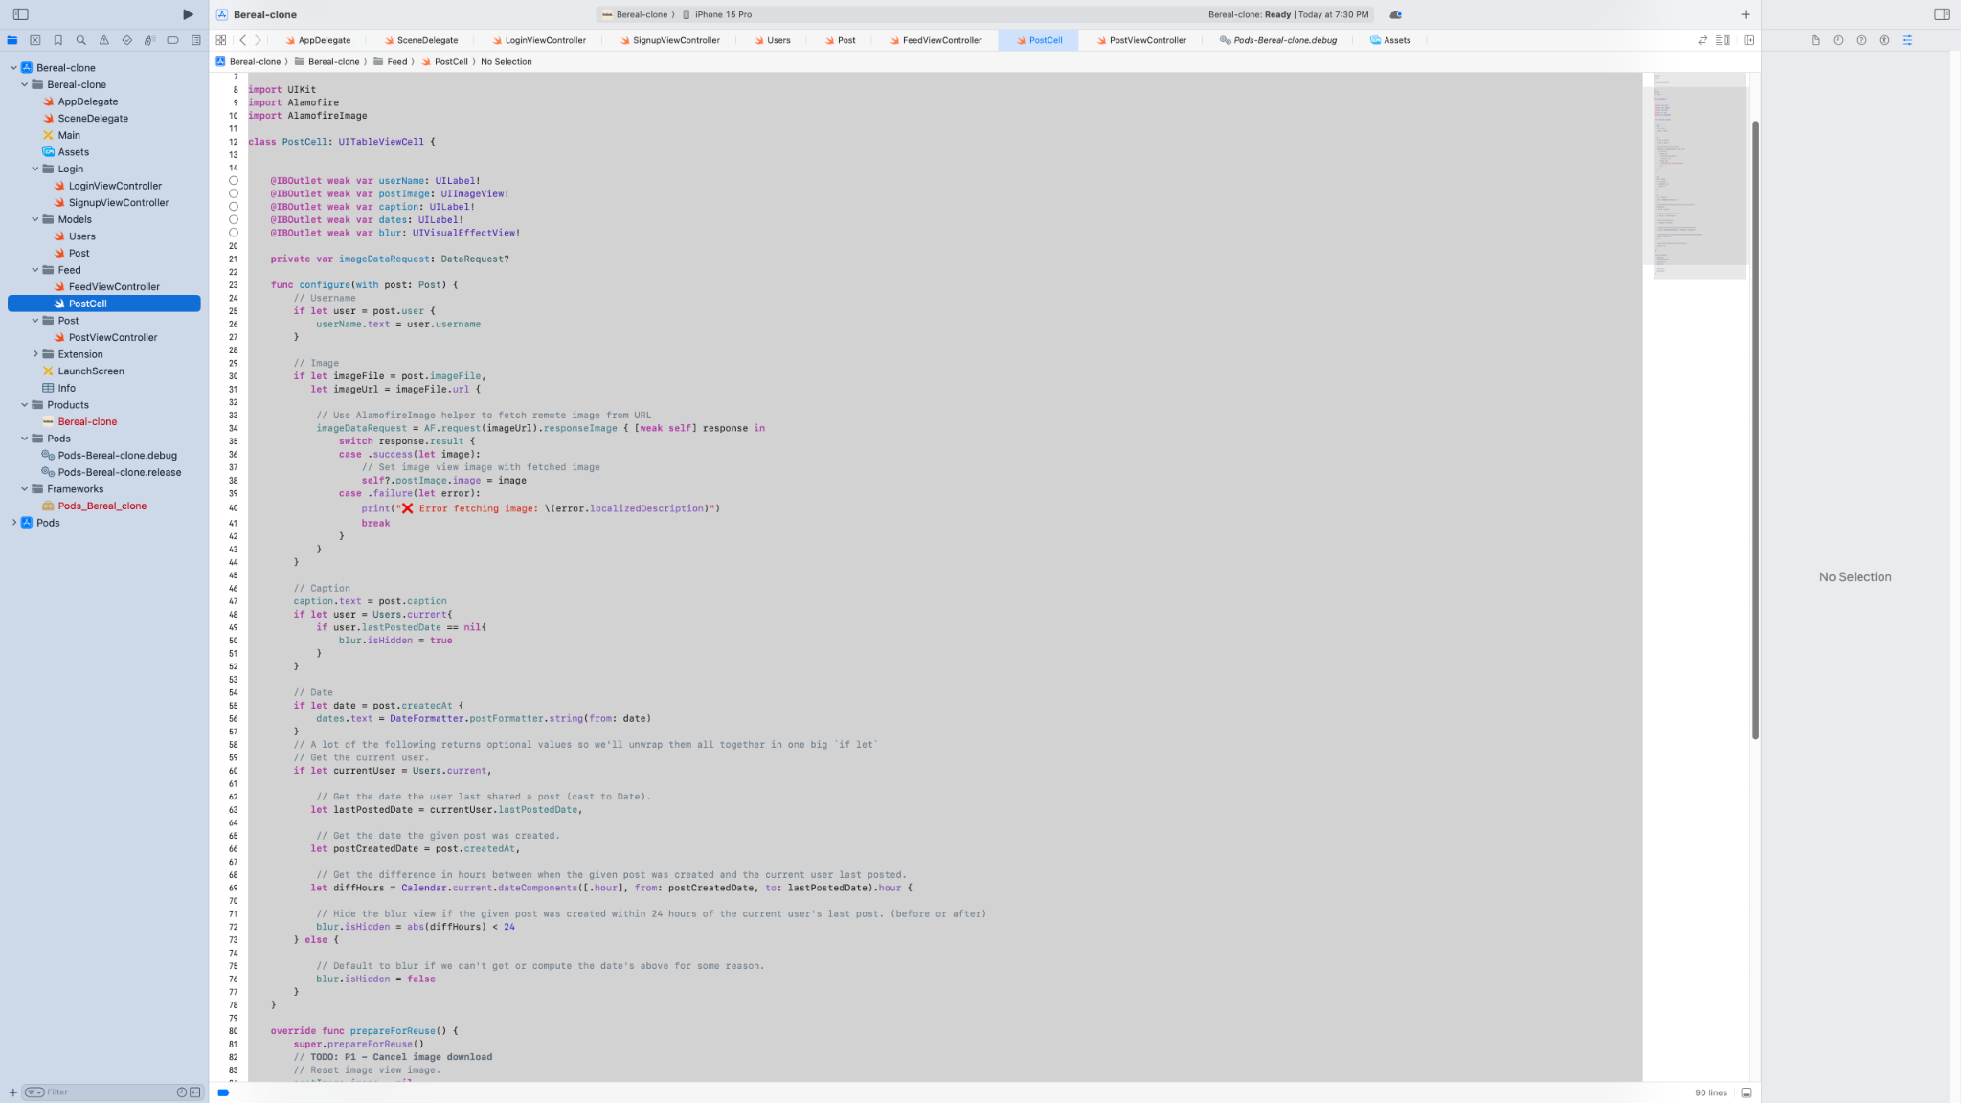

PostViewController.swift (1/3)

UI to pick image and enter caption before posting.

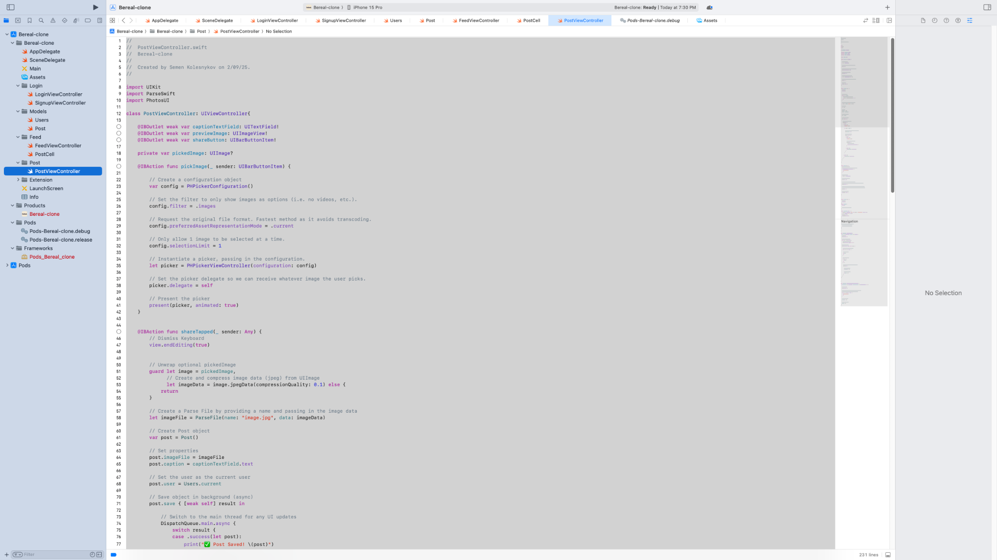

PostViewController.swift (2/3)

Saves the post to the server and updates the user's last post date.

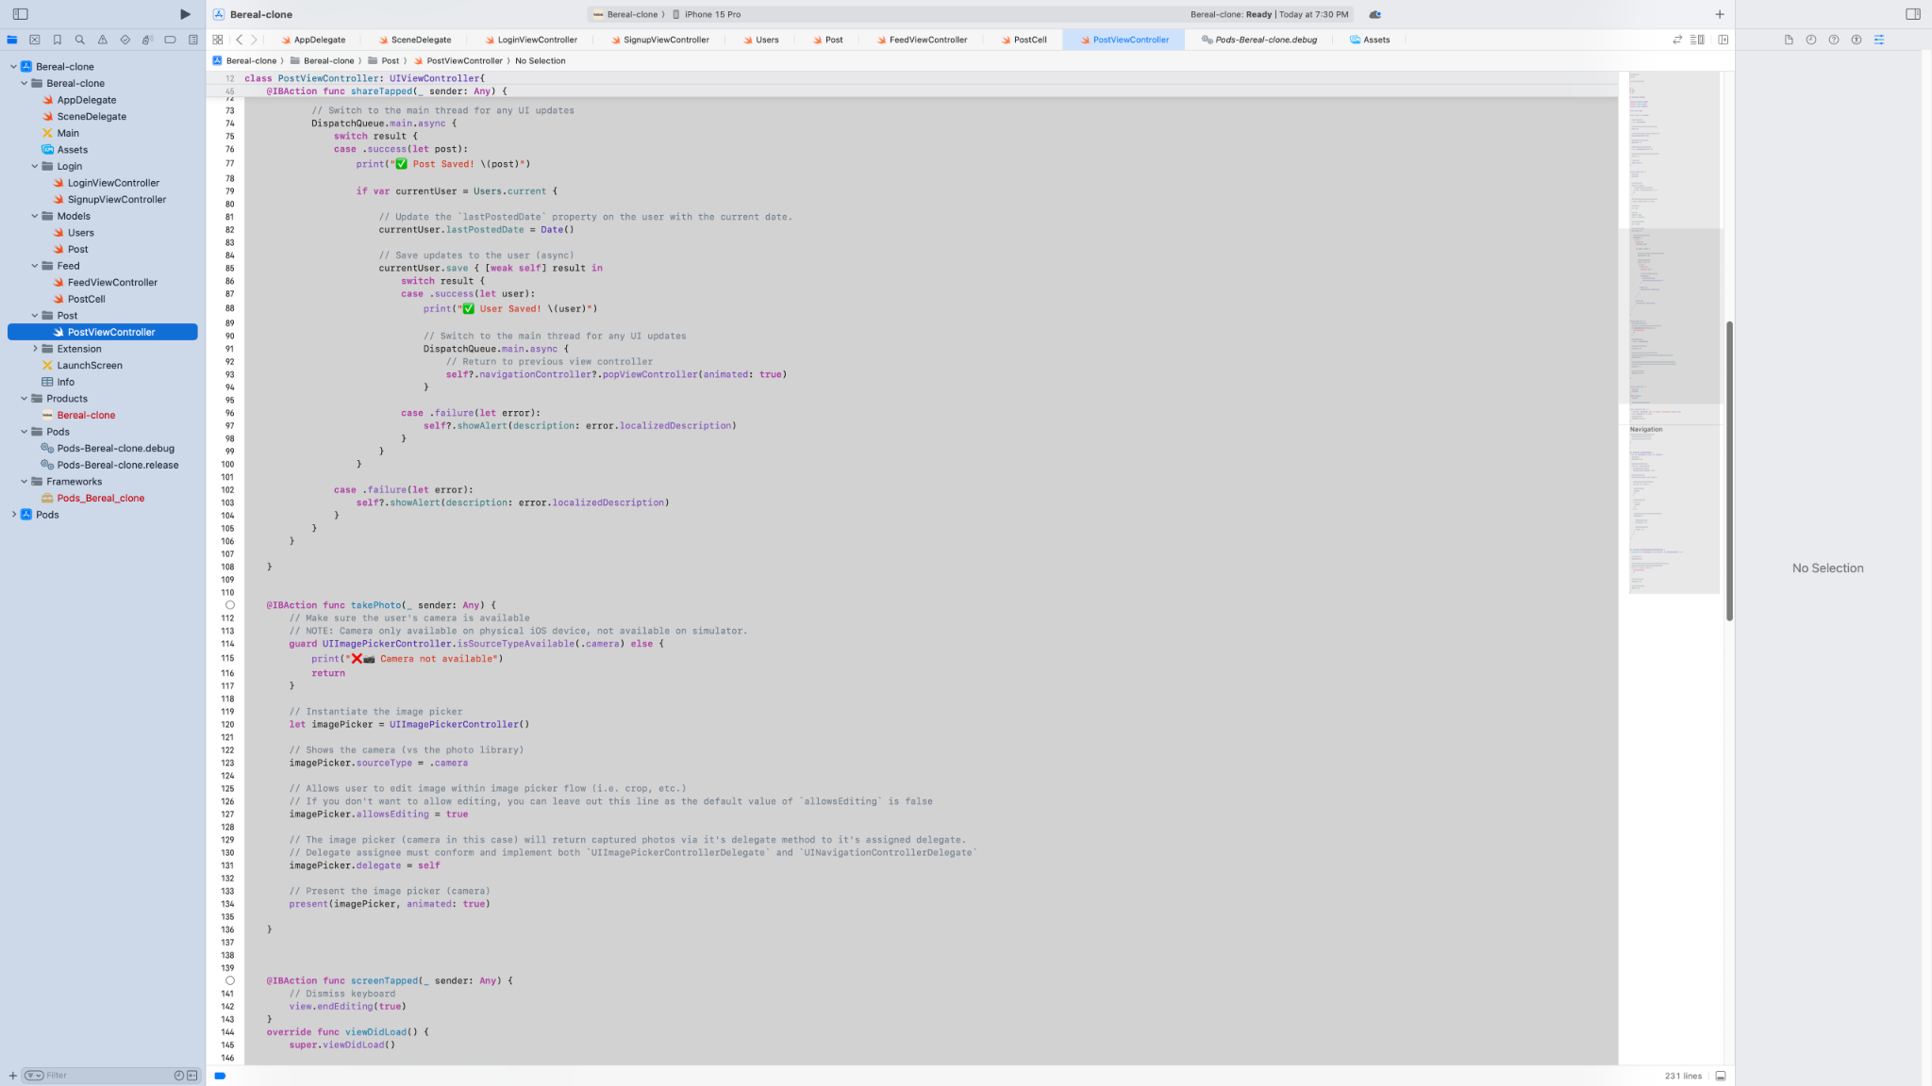

PostViewController.swift (3/3)

Implements PHPickerView and UIImagePickerController delegates.

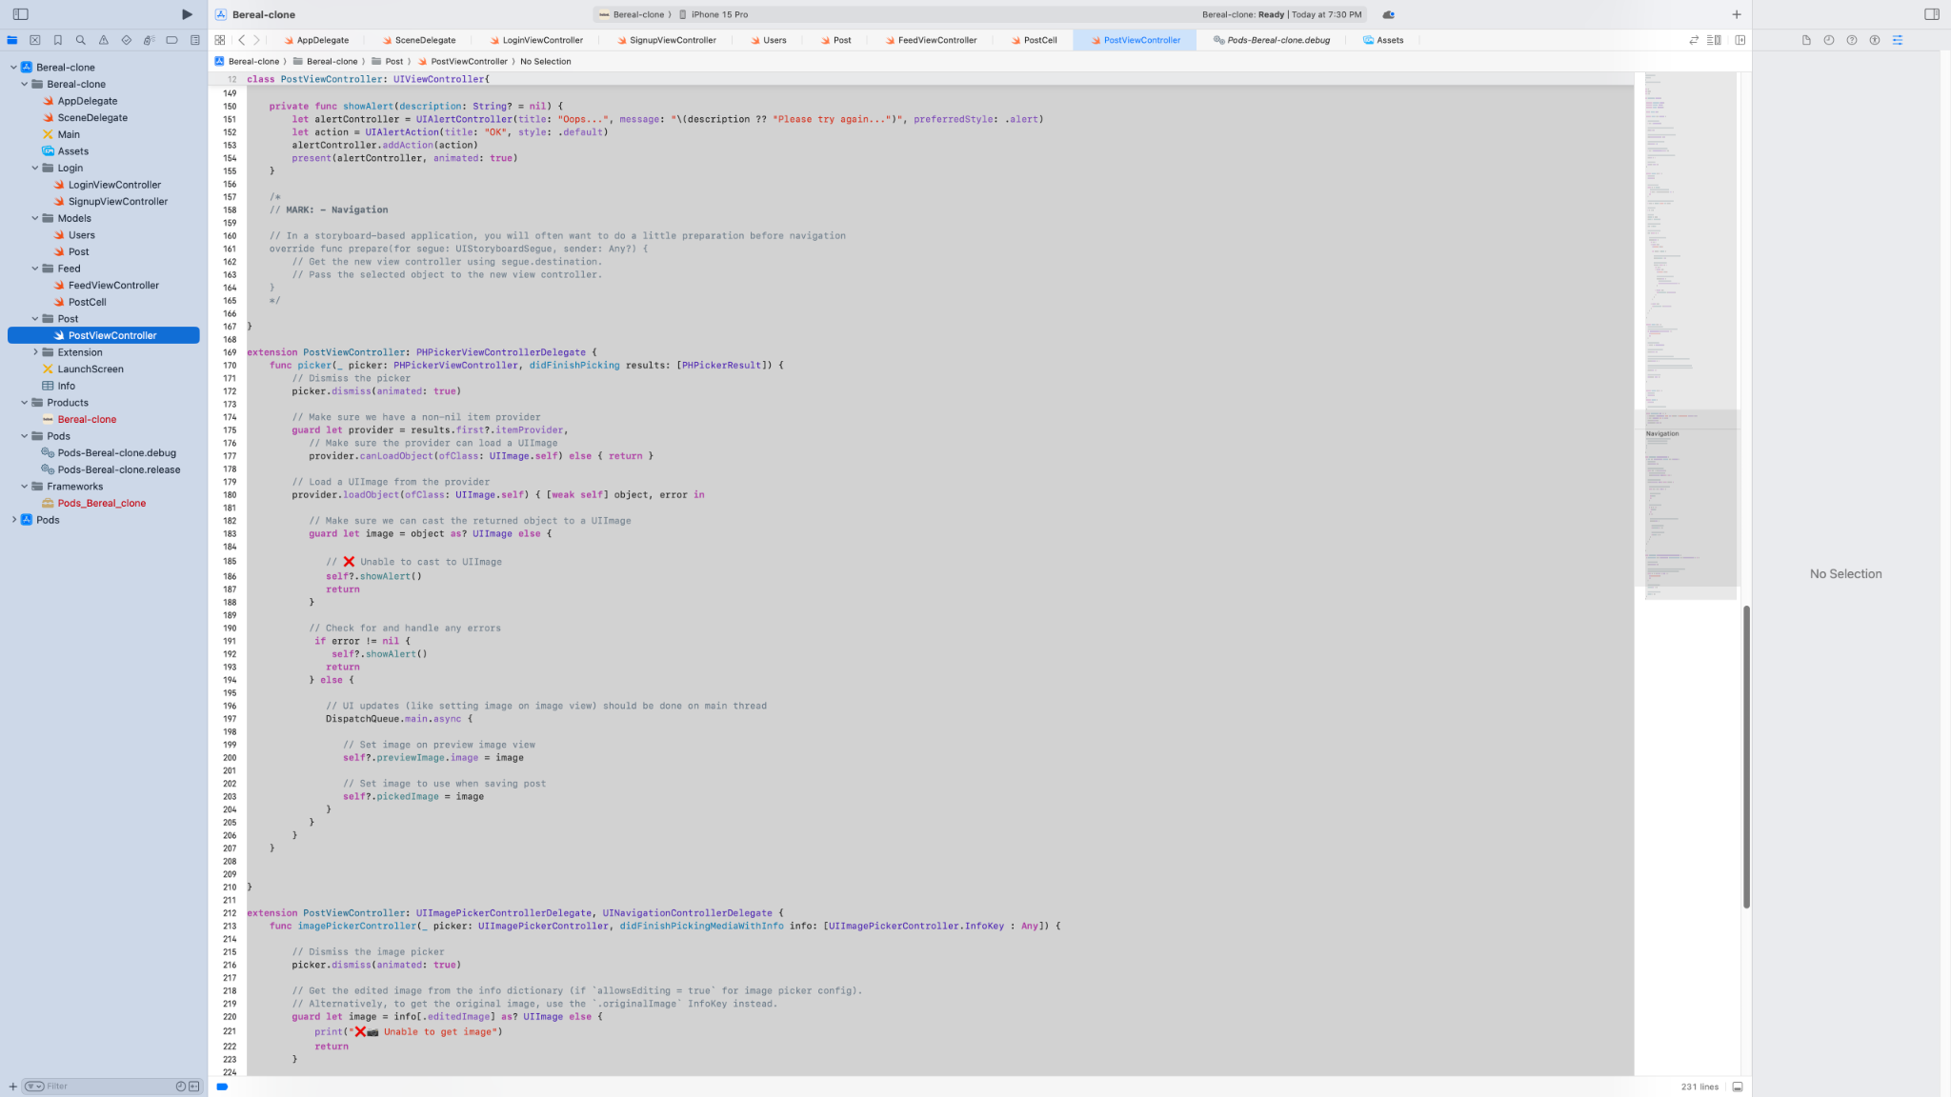

Users.swift

Defines the Parse user model including custom fields.

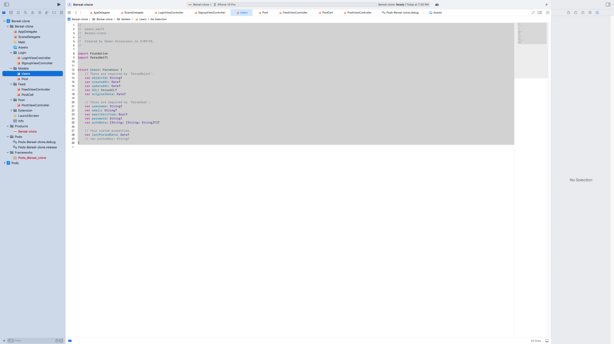

Post.swift

Defines the Parse post model.

